

**Official Newsletter for the  
International Organization of Wooden Money Collectors *Celebrating Our 55th Year***

**Volume LV July2019 Issue 7**

***founded July 1964***

**HAPPY BIRTHDAY MY GRANDCHILDREN**

**Submitted by: Anatoly Saltykov-Karpov, PhD, New-York**

A tree accompanies a person throughout his life and even earlier. When he is in the womb, then the expectant mother walks through the forest and inhales its aromas. When the baby sleeps in a wooden crib. When she comes into the toy store and tries to choose environ- mentally friendly, useful, informative, she is faced with a huge number of wooden models.

Undoubtedly, a huge number of manufactured children's wooden toys are useful and necessary. Locomotives, cars, various animals and others carry important educational properties. However, often in conversations between parents, relatives and friends there are conversa- tions about money. Such conversations are important when a child loses very expensive things or breaks toys. He has to explain the con- nection between hard work of parents, making money and buying toys.

Of course, it would be possible to use real money in a game version or use sham paper. Real money can carry infectious bacteria and can be dangerous especially for small children as they are small. A child can swallow them. A child may damage tooth enamel when biting a metal coin. Therefore, in this process, you can use wood money. Informational properties of wooden money can be used as both mathe- matical, mystical, geographical and social sources. They begin to shape the future consciousness of the child, as a citizen. Mathematical is learning to count instead of traditional wooden counting sticks. Simultaneously with this process, the motor develops the motility of the fingers and hands. Stamps, dollars, rubles, euros, etc. allow you to familiarize the child with the versatility of the world. The most important are social, related to family traditions. The most effective - this phenomenon will occur during the celebration of birthdays. On this occasion, you can issue a special wooden coin. On this coin, you can print the year of issue, name and portrait. This coin can be distributed to guests.

The next moment may be related to the development of the sociability and adaptation of the child as a person in society. For example, in a large family used to play coins with the images of different children. As a result of such a game, a sense of ownership, sociability, enter- prise is instilled, and the foundations of commodity-money relations are also developing. Natural phenomena are often used in life and business. This may be a result of mystical interaction alive and lifeless nature and the search for new ideas.

There are teachings that prove the connection of human consciousness with the consciousness of the world around it. It is a symbol of the world, which is the maternal care and vitality. What is the power?

For example, birch is a symbol of human life and cosmic energy. Birch attributed the way to summon good spirits and drive out evil. Oak is the strength, endurance, longevity and nobility. Wood - a natural symbol of the highest dynamic growth, seasonal death and regeneration. In various cultures, many trees were considered sacred and magical. Respectful attitude to the magic power of trees is based on the popular belief that the gods and spirits live in them.

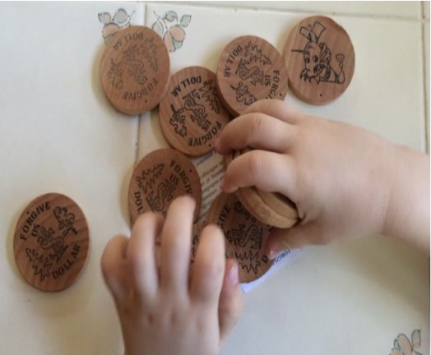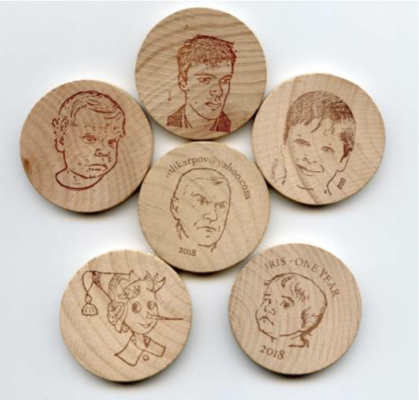

Coins in grandfather games with grandchildren and granddaughter.



**Official Newsletter for the  
International Organization of Wooden Money Collectors *Celebrating Our 53rd Year***

**Volume LIII May 2017 Issue 05**

***founded July 1964***

page 6

**FORGIVE US (ME) MONEY (DOLLAR) (A new perspective on wooden coins)  
Karpov Anatoly, Ph.D., New York**

In the Russian market and to create the formation of the ruble was popularly wooden name of democracy. At this time, one dollar was exchanged for 6 rubles. Over the past two decades in Russia's problems on the market has led to what is now a dollar is exchanged for 65 rubles. The author worked as a teacher at the St Petersburg Forest Technical Academy(Russia). He made wooden ruble and used it as a souvenir business.

Figure .1,2. Stamps and wooden rubles and dollars, manufactured in Russia.

By tying the production of wooden ruble to natural phenomena. On the one hand printed sign of the ruble, and on the other side of the sign of the company where he worked as a co-owner. During the Soviet era in the ruble had big problems. The country has built communism. The role of money and the private sector has been limited. The Soviet people had to build a new society selflessly. Therefore, the author proposed to use a wooden ruble repentance action. The Communists built an atheistic state. The dollar was the currency of the forbidden. To support the wooden ruble author has made his fellow wooden dollars for bioenergy support. This action reduced the level of anti-Americanism.

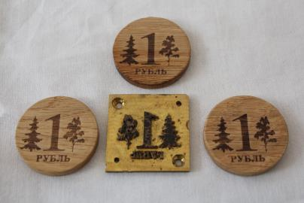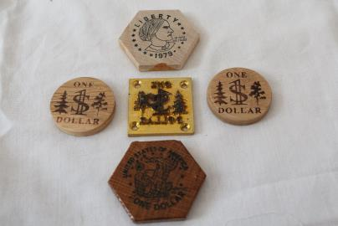

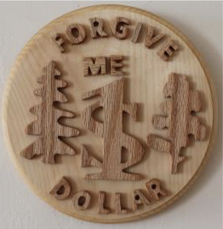

Figure 3. Wall wooden dollar meditation.

The author moved to the United States. Studying the history of the America he discovered that here in difficult times use a wooden coin for calculations and payments. Currently, the role of a wooden dollar increases. It is of great socio-political importance in connection with the problems of formation of market democracy in countries such as Russia. To start, it is proposed to promote the historical example of the use of wooden money in difficult times for the United States. Perform the action: "Forgive us dollar". Such way across the ocean to reach out to his fellow wooden ruble, which fell in a difficult position. Create consolidating bases with wooden ruble and other currencies. United States - the leader of the country. It should show tolerance in exchange relations on a wooden base. Anyway wooden dollar could say: «Forgive us wooden ruble. It's nothing personal – it's business». In the real paper and metal money, it is advisable to print the phrase: "Forgive us dollar."



**PHILOSOPHY AND CONSCIOUSNESS OF THE WOODEN BITCOIN, HIS BROTHERS AND SISTERS Anatoly Karpov, PhD, New York**

Modern technology has changed the traditional cash payments. This led to the emergence of electronic payment and cashless pay- ments. The creation of the Internet has led to the creation of electronic money. Purely material expression in the form of dollars and other money was gone. Money turned into bits of information and electrical signals. For active movement of such information requires continuous and infinite birth of ideas (projects). Ideas often come from the world of fantasy and fairy tales. An important component of a material part of the birth of such ideas is a tree. Since ancient times, people have always worshipped wooden idols or icons. The Internet can be regarded as a natural analogy of a forest that cover our planet. As an example of Oaks and birches grow in Europe and America. Faith and interacting with them created in people a sense of security. Gave hope for the future. Tree – is the highest natural symbol of the dynamic growth, seasonal death and regeneration. In various cultures many trees ...were considered sacred and magical. Respectful attitude to the magic power of trees is based on the popular belief that the gods and spirits live inside of the trees.

Recent studies of American scholars on neuroscience in the field of consciousness and show that it has even the stones. Therefore we can based on the works of panpsychists believe that wooden coin will have some form of consciousness.

Intuitive notion born “forgive us ruble or dollar” actually has a deeper philosophical meaning. It comprehensively incorporate the rela- tionship real, including electronic bitcoin with wood, like icons, human and Christian repentance.Therefore, the materialization and use wooden coins allows you to improve the interaction between real money and society. Below are present wooden coins.

